FAST School of Computing, National University of Computer and Emerging Sciences, Islamabad

Data Analysis and Visualization

Lab Manual 2

Lab Learning Outcomes:

- Understand visual encoding ; how marks and channels (position, length, color, size, shape) translate data into meaningful visuals
- Select and construct the appropriate chart type (bar, line, histogram, box, scatter, area) for a given dataset and question
- Detect outliers visually using box plots, and verify them analytically using IQR and Z-score methods
- Identify graphical integrity issues (e.g., truncated axes, misleading scales) that distort honest interpretation of data

Submission Requirements:

- Submit notebook (.ipynb) + cleaned dataset (.csv) on both GCR and GitHub , incomplete without both
- GitHub: push into your section repo, inside the week's folder, in your own subfolder named RollNumber_Section (e.g., 24F1234_5A)
- GCR: file naming convention RollNumber_Section_LabXX (e.g., 24F1234)
- Keep your GitHub subfolders updated weekly , a complete, organized profile is checked at the Capstone stage (Week 15–16)

Outliers in Dataset

- IQR (Interquartile Range) Method

What it measures: the spread of the middle 50% of your data, and flags anything unusually far outside that range.

How it works: Q1 is the value below which 25% of your data falls; Q3 is the value below which 75% falls. IQR is the width of that middle box. The 1.5 multiplier is a long-standing statistical convention (from Tukey's original boxplot method) , anything beyond 1.5× the box width on either side is considered unusual.
Strengths: doesn't assume any particular distribution shape; robust to a few extreme values since it's based on quartiles, not the mean.
Weakness: breaks down on heavily skewed or zero-inflated data (like capital-gain) , it can flag thousands of legitimate values as "outliers" simply because the bulk of the data sits at zero, making the box artificially narrow.

- Z-score Method

What it measures: how many standard deviations a value is from the mean.
How it works: it calculates (value - mean) / standard deviation for every row. A z-score of 3 means a value is 3 standard deviations above the average , statistically rare in a normal distribution (only about 0.3% of data would naturally fall beyond ±3 in a perfect bell curve).
Strengths: simple, intuitive, works very well when data is roughly normally distributed (bell-curve shaped) , good for something like age.
Weakness: the mean and standard deviation themselves are sensitive to extreme values , if a column has a few huge outliers, they inflate the standard deviation, which can actually hide other outliers by making the "normal range" seem wider than it should be. Also performs poorly on skewed data, same issue as IQR but for a different reason , z-score assumes symmetry around the mean, which skewed data doesn't have.

- Percentile Capping (Winsorization)

What it measures: simply defines outliers as anything below a low percentile or above a high percentile , no statistical formula, just a fixed cutoff.

How it works: you decide upfront , "I'll treat the bottom 1% and top 1% of values as outliers," regardless of whether the data is skewed or not.
Strengths: very simple, predictable , always flags exactly the same proportion of data (e.g., always ~2% total), regardless of the column's shape.
Weakness: it's somewhat arbitrary , the 1%/99% cutoff isn't based on any statistical reasoning about what's "normal" for this specific column, just a fixed rule you impose.

- Domain Knowledge Rules

What it measures: outliers based on real-world business logic, not statistics at all.
How it works: you use knowledge about what's physically or logically possible , age can't be negative, a percentage can't exceed 100, hours worked per week can't realistically exceed 168 (the total hours in a week).
Strengths: catches genuine data errors (impossible values) that statistical methods might miss entirely if the error happens to fall within a "normal-looking" range.
Weakness: requires someone who understands the subject matter , it's not a formula you can apply blindly to any column; you have to know what's realistic for each specific field.

- Model-Based Methods (Advanced)

These use machine learning to detect outliers, typically taught in a Machine Learning or Data Mining course:
- Isolation Forest , builds random decision trees and measures how "easy" it is to isolate a point from the rest of the data; outliers get isolated in fewer steps than normal points
- DBSCAN (clustering) , groups data into dense clusters; points that don't belong to any cluster are flagged as outliers
- Local Outlier Factor (LOF) , compares a point's density to its neighbors' density; points in sparser regions than their neighbors are flagged as outliers

Visual Encoding of data

Visual encoding is the process of translating data values into visual properties , position, length, color, size, shape , so that a person can look at a chart and understand the underlying numbers without reading a table of raw values.
Every chart you've ever seen is really just data being mapped onto some visual property. A bar chart's height encodes a number. A scatter plot's position encodes two numbers at once (x and y). A heatmap's color encodes a number. The "encoding" is the rule connecting the data to what you see.

The building blocks
- Marks = the basic geometric object drawn on the chart , a point, a line, a bar, an area
- Channels = the visual property used to represent a data value through that mark , position, length, color, size, shape

Five Channels

- Position , the strongest, most accurate channel. Humans are extremely good at comparing where two points sit relative to each other (this is why scatter plots and bar charts, which rely on position, are usually the most trustworthy chart types)
- Length , very accurate, almost as good as position (bar chart heights use this)
- Color , good for showing categories (different colors = different groups), but weak for showing precise quantity , people are bad at accurately judging "how much more" one shade of blue represents versus another
- Size , weaker than position/length for precise comparison , humans are notoriously bad at accurately comparing the area of two circles or bubbles (this is a common criticism of bubble charts)
- Shape , good only for distinguishing categories (circle vs. triangle vs. square), essentially useless for representing quantity

You choose your chart type based on which channel best matches what you're trying to show, not based on which chart "looks nicest."
- Comparing categories → bar chart (uses length/position , the strongest channels)
- Showing a trend over time → line chart (uses position along a continuous axis)
- Showing distribution shape → histogram (uses position + area)
- Showing spread and outliers → box plot (uses position for quartiles/whiskers)
- Showing relationship between two numeric variables → scatter plot (uses position for both variables at once)
- Showing part-to-whole composition over a continuous range → area chart (uses position + shaded region)

Choosing Encodings , the core principle

Tell students: "Every chart type is really just a different way of using position, length, or color to represent numbers. Choosing the right chart means matching the type of question you're asking to the encoding that answers it most accurately , not picking whichever chart looks nicest."

The decision generally comes down to three questions:
- How many variables am I showing? (one column, or the relationship between two?)
- What type is each variable? (categorical/text, or numeric?)
- What am I trying to learn? (a comparison, a trend, a distribution, a relationship, or a composition?)

- Bar Chart

Use for: comparing a numeric value across categories (e.g., average hours-per-week by occupation, or count of people per education level).

Why it works: bars use length and position , the two strongest, most accurately-judged visual channels (this is the same reasoning behind Comparison 3 above, where a bar's length made "2x" obvious, but a circle's size didn't).
Data type needed: one categorical column (x-axis) + one numeric column (y-axis), or just categorical counts.

- Line Chart
Use for: showing a trend over an ordered sequence , almost always time, but can be any naturally ordered variable.

Why it works: a connected line lets your eye follow the direction of change continuously , this is exactly the point made in Comparison 4 above, where the same data as disconnected bars made the trend hard to see, but as a line it was immediate.
Data type needed: an ordered numeric or time-based x-axis, numeric y-axis. Caution to teach: never use a line chart on categories with no natural order (e.g., connecting bars of race categories with a line implies an order that doesn't exist , a common misuse).

- Histogram
Use for: showing the distribution shape of a single numeric column , is it symmetric, skewed, bimodal?

Why it works: it groups values into bins and uses bar height (length) to show how many values fall into each range , this is the "visual EDA" tool from Lab 1, now formalized as a proper chart type with axis labels and titles.
Data type needed: one numeric column only.

- Box Plot
Use for: showing spread, quartiles, and outliers for a numeric column , optionally broken down by category.

Why it works: this is Comparison 5 above , a single average bar hides the outliers entirely, while a box plot shows the middle 50% (the box), the normal range (whiskers), and flags outliers as individual dots. This is the exact mechanism you already taught with the IQR formula , the chart is just drawing that calculation.
Data type needed: one numeric column, optionally grouped by one categorical column.

- Scatter Plot
Use for: showing the relationship between two numeric variables , does one tend to increase/decrease with the other?

Why it works: each point uses position on two axes simultaneously , the strongest possible encoding, since you're reading two numbers from a single dot's location.
Data type needed: two numeric columns. Not for categories , plotting a scatter of education vs marital-status doesn't make sense since there's no meaningful position to place category names at.

- Area Chart
Use for: showing a trend over time plus a sense of accumulated volume/magnitude, or a part-to-whole breakdown over time (stacked area).
Why it works: it's a line chart with the region underneath filled in , the fill draws attention to magnitude, not just direction, which is useful when the total volume matters as much as the trend.
Data type needed: same as line chart , ordered numeric/time x-axis, numeric y-axis. Caution to teach: area charts can visually exaggerate magnitude due to the filled region , use only when that emphasis is actually warranted, otherwise a plain line is more honest.

- Graphical Integrity
This is the overarching rule that governs all five chart types above , a chart's visual proportions should match the real proportions in the data, never exaggerate or minimize them for effect.

Examples:

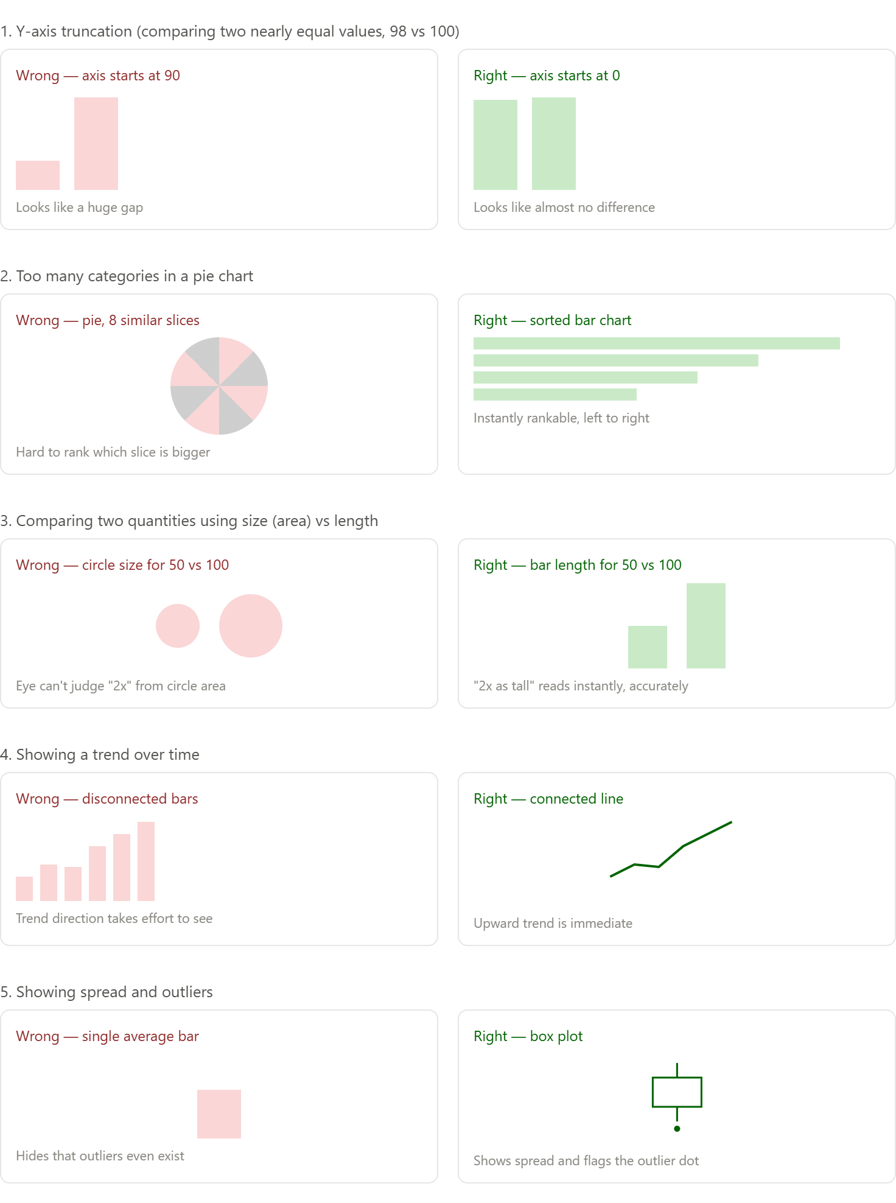

Lab Tasks:
Choose ONE of the following three datasets to complete all tasks below.
Datasets: Adult_income, Pengius and Tips dataset.

Task 1 : Bar Chart: Compare a Category
Create a bar chart comparing a numeric column's average across a categorical column (e.g., average bill by day, average body mass by species, average hours-per-week by occupation). Label your axes and title the chart.

Task 2 : Count Plot: Category Frequency
Create a count plot showing how many records fall into each category of one categorical column. Which category is most common?

Task 3 : Histogram: Distribution Shape
Create a histogram of one numeric column. Describe its shape in one sentence , is it symmetric, skewed left, or skewed right?

Task 4 : Box Plot: Visual Outlier Detection
Create a box plot of the same numeric column from Task 4, optionally split by a category. Identify how many outlier points (if any) appear beyond the whiskers, just by looking.

Task 5 : Outlier Detection: The Mechanism (IQR)
Using the same column from Task 4, calculate the IQR bounds manually:

Q1 = df['col'].quantile(0.25)
Q3 = df['col'].quantile(0.75)
IQR = Q3 - Q1
lower = Q1 - 1.5 * IQR
upper = Q3 + 1.5 * IQR
outliers = df[(df['col'] < lower) | (df['col'] > upper)]
print(len(outliers))

Compare this count to what you visually counted in Task 5 , do they match?

Task 6 : Outlier Detection: Z-score Comparison
Run the z-score method on the same column:

from scipy import stats
df['zscore'] = stats.zscore(df['col'])
outliers_z = df[df['zscore'].abs() > 3]
print(len(outliers_z))

Do IQR and z-score flag the same number of outliers? If not, explain why, referencing whether your column's distribution is symmetric or skewed (from Task 4).

Task 7 : Scatter Plot: Relationship Between Two Variables
Create a scatter plot between two numeric columns. Does there appear to be a relationship (positive, negative, or none)? Color the points by a categorical column if one is meaningful for your dataset.

Task 8 : Line/Area Chart: Trend Across an Ordered Variable
Since none of these datasets has a true time column, choose an ordered variable instead (e.g., sorted bill_length_mm bins for Penguins, day for Tips, education-num for Adult) and plot the average of a numeric column across it as both a line chart and an area chart. Compare how the area fill changes the visual impression versus the plain line.

Task 9 : Graphical Integrity Check
Take your bar chart from Task 2 and deliberately re-plot it with a y-axis that does not start at zero (plt.ylim(bottom=X) with some X above the minimum value). Compare the two versions side by side and write 2-3 sentences explaining how the truncated axis changes the impression of the data, even though the numbers haven't changed.

